The first alternative strategy is a two-burn maneuver that has been chosen as the best compromise between the cost and the time of maneuver. In order to find the maneuver, it firstly has to be searched the two-burn maneuver that is able to minimize as much as possible the total cost.

This maneuver has been realized through a MATLAB function that is able to return a set of possible secant maneuvers (these ones discretize an infinite range of maneuvers), given the initial point and the final point of the maneuver. Indeed, the burns can be arbitrarily directed into space: only the orbital plane remains constant, since it is the only one passing through the three known points (the initial and the final ones and the focus of the orbit). Therefore, the parameters $i, Ω, u_{i}, u_{f}$ remain unchanged, while the parameters $a, e, ω, θ_{i}, θ_{f}$ will vary according to a chosen parameter.

So, the problem is underdetermined and therefore there are infinite orbits that can solve the problem: it is convenient to parametrize the perigee argument $ω$ by discretizing the range between 0 and $2π$, selecting successively the valid orbits. To do this, it has been used MATLAB to study the eccentricity as a function of $ω$ through its graph; the shape of the latter remains similar for all the cases analyzed, it always has just one range of $ω$ for which the eccentricity is acceptable (between 0 and 1):

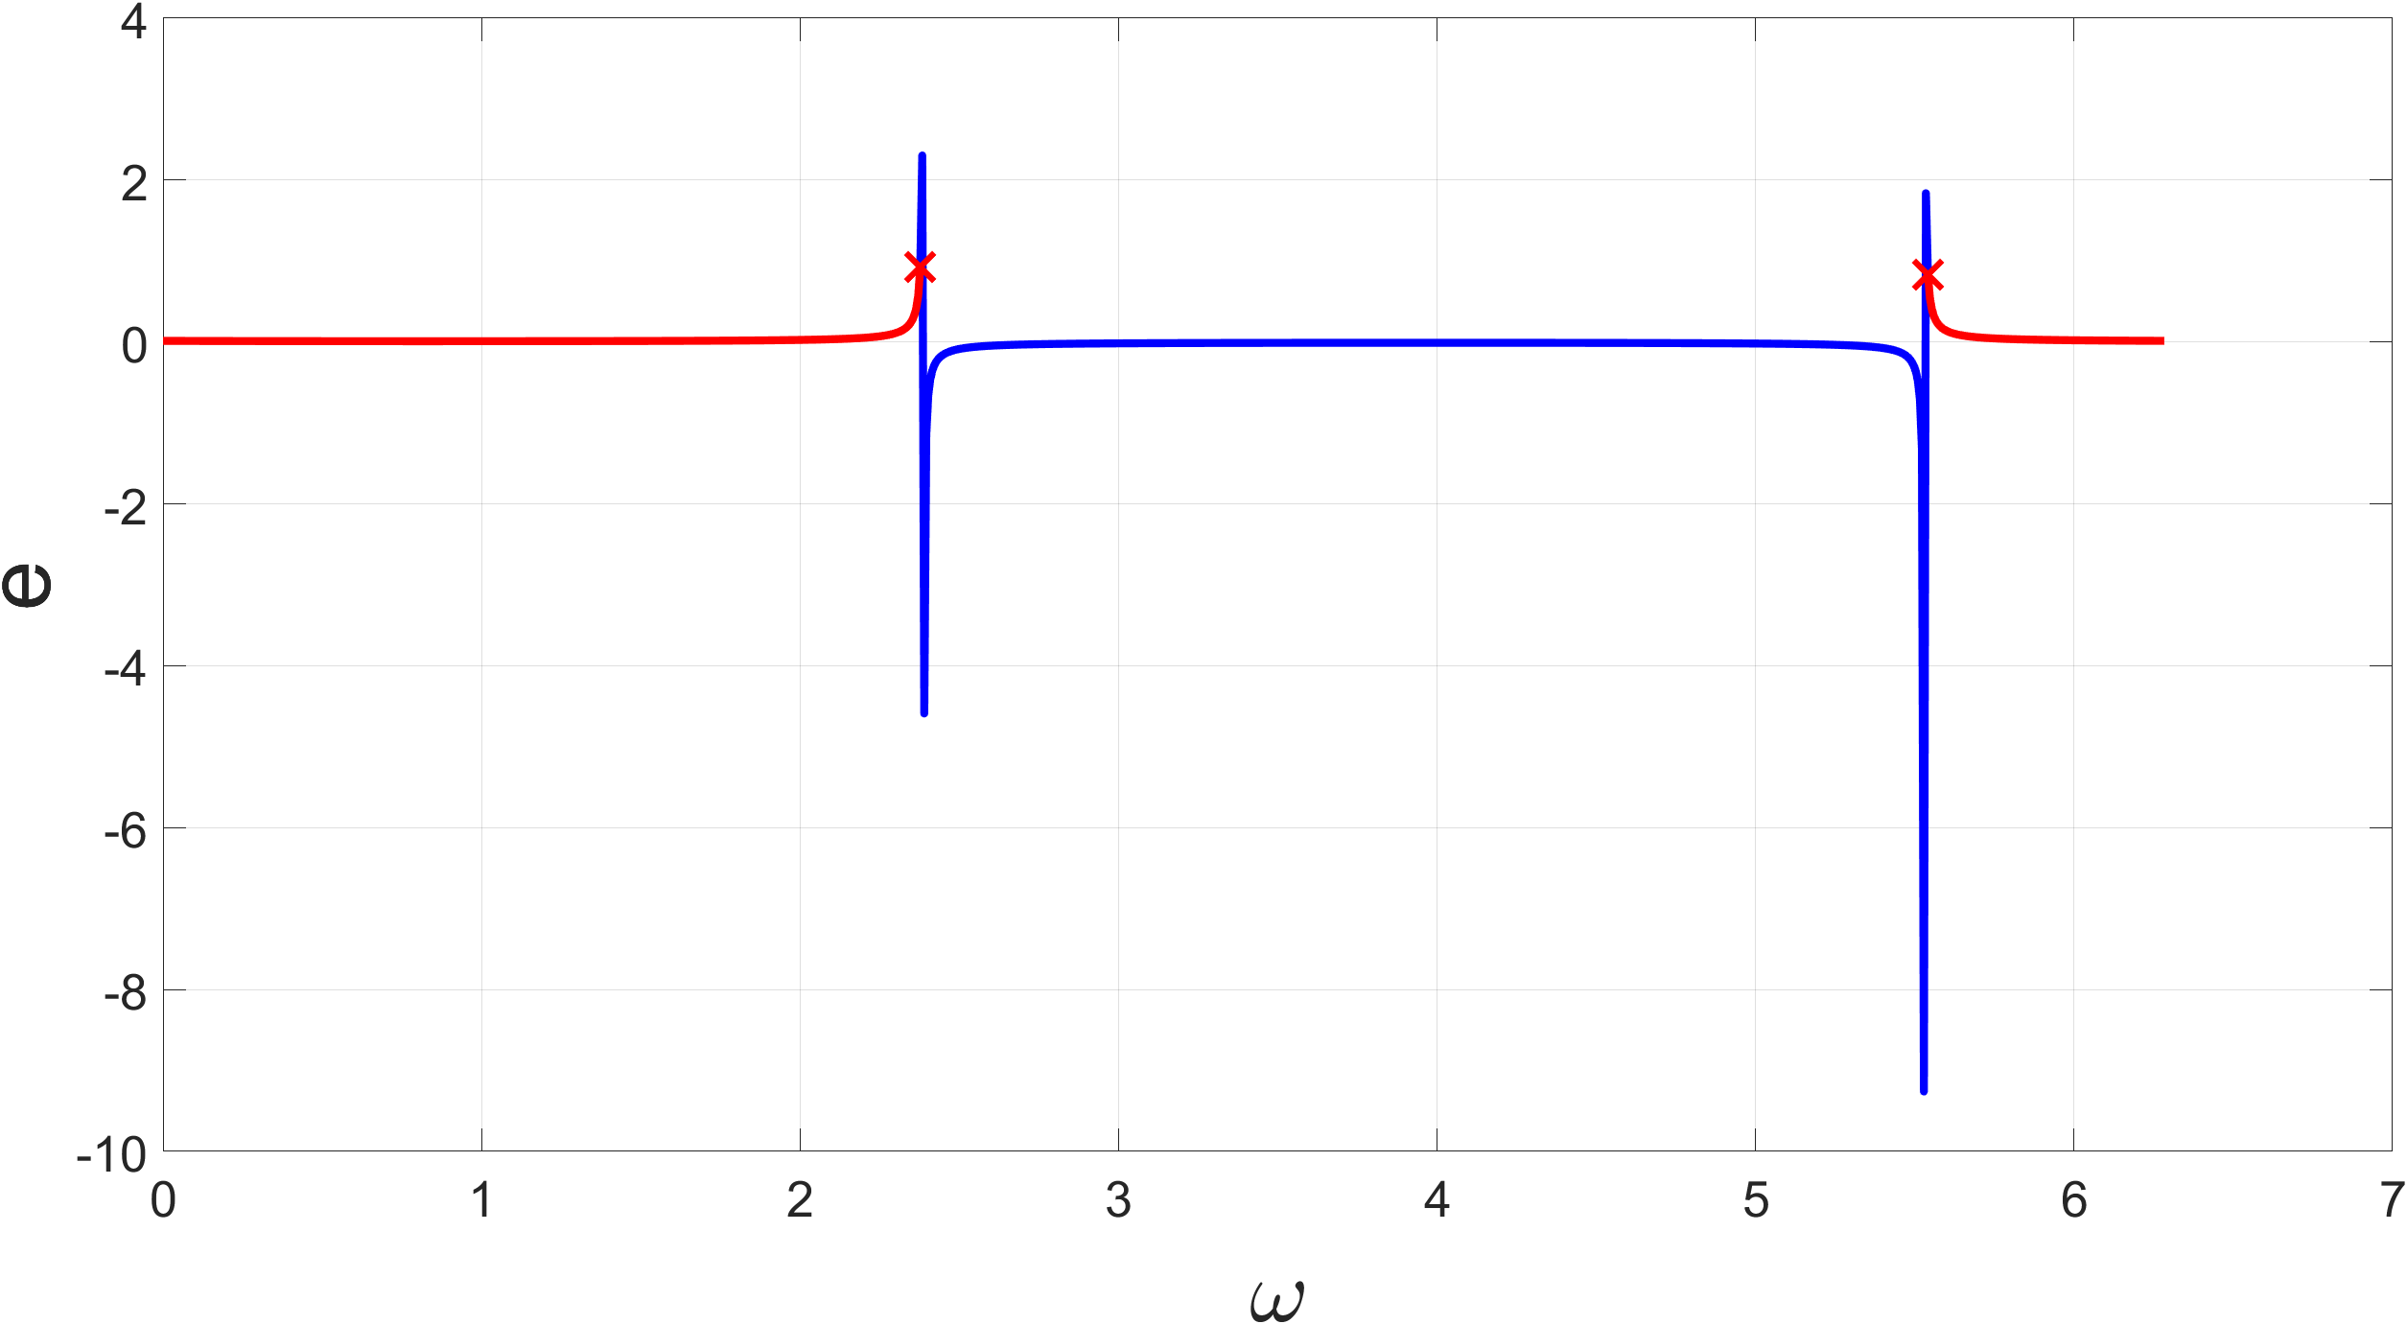

By isolating the range and discretizing it, it is possible to determine the remaining orbital parameters, to define a set of orbits passing through two points and to calculate the cost and the time of the various orbital transfers.

By using the function described above, it has been defined an iterative process consisting of two nested for-loops that can vary the initial and the final points, discretizing the initial and the final orbits through their orbital parameters; among the analyzed orbits, it has been found the one with the lowest total cost.

Starting from this orbit, it can be realized that the point of maneuver that has been chosen on the initial orbit is slightly rear from the initial point, and that the greatest amount of time used by the satellite is spent on the course the satellite accomplishes on the initial orbit (almost an entire orbital period). By knowing this, the initial point of maneuver has been fixed on the starting point, and the code has been re-adjusted by varying only the point on final orbit within the loop. The result is a secant transfer, whose total time is about halved (reduced by 46.96% compared to the previous one), while the total cost is increased by only 1.54%.